

**BOOKS SHOPPING ONLINE**

Software Requirement Specification

**Team 3**

– Hanoi, May 2023 –

**Table of Contents**

**I. Overview**

1. Introduction **4**

2. System Functions **5**

3. Entity Relationship Diagram **16**

4. Entities Description**17**

**II. Functional Requirements**

**1. Public Feature**

a. Home Page **18**

b. Blog List **20**

c. Blog Detail **21**

d. Products List **22**

e. Products Details **24**

f. Feedback **26**

g. Cart Detail **26**

h. Cart Contact **27**

k. Cart Completion **28**

**2. Common Feature**

a. User Login **30**

b. User Register **31**

c. Reset Password **32**

d. Change Password **33**

e. User Profile **34**

f. User Authorization **37**

**3****. Customer Feature**

a. My Orders **38**

b. Order Information **39**

**4****. Marketing Feature**

a. MKT Dashboard **40**

b. MKT Product List **41**

c. MKT Slider List **43**

d. MKT Product Detail **44**

e. MKT Slider Detail **45**

f. MKT PostsList **46**

g. MKT Posts Detail **47**

h. MKT Feedback List **48**

j. MKT Feedback Detail **49**

k. MKTCustomer List **50**

l. MKT Customer Detail **52**

**5****. Sale Feature**

a. Sale Dashboard **52**

b. Orders List **53**

c. Order Details **54**

**6****. Admin Feature**

a. Admin-dashboard **55**

b. User List **56**

c. User Detail **58**

d. Setting List **59**

e. Setting Detail **61**

# I. Overview

## 1. Introduction

The online book buying system is a Web application that replaces the physical selection processes that make it easy for customers to choose and pay for it. With a diverse product development system, customers do not have to go to the selection site but can stay at home and freely choose the right models for themselves. This system is expected to develop after updating new features and promises to be completed as soon as possible to introduce to consumers.

Marketing information: Posts list, Sliders list, Products list, Feedbacks list.

## 2. System Functions

#### a. Screen Flow

#### b. Screen Details

| **#** | **Feature** | **Screen** | **Description** |
| --- | --- | --- | --- |
| 1 | Public | Home Page | Show sliders, hot posts, featured products + the slider with the latest posts, static contacts/links  - Shown slider information includes its image and title; the user is redirected to the slider's backlink on his/her clicking  - Shown post information includes its thumbnail, title, brief-info; the user is redirected to the post's details on his/her clicking  - Shown product information includes its thumbnail, title, brief information; the user is redirected to the product's details on his/her clicking |
| 2 | Public | Blogs List | Show the posts paginatedly (sorted by updated date, paginated) + the sider with the post search box, post categories, the latest posts, and static contacts/links; Shown post information includes its thumbnail, title, brief-info; the user is redirected to the post's details on his/her clicking |
| 3 | Public | Blog Details | Show post details (including title, author, updated date, category, and post details) + the sider with the post search box, post categories, static contacts/links |
| 4 | Public | Products List | Show the products paginatedly (sorted by updated date) + the sider with the product search box, product categories, the latest products, and static contacts/links;  - Shown product information includes its thumbnail, title, brief information, original price, and sale price;  - The user is redirected to the product's details on his/her clicking on the product  - The user can choose to add the product to the cart or to feedback on the product by clicking the product's Buy & Feedback buttons responsively |
| 5 | Public | Product Details | Show product details (including title, category, images, original price, sale price, and product details) + the sider with the product search box, product categories, the latest products, and static contacts/links |
| 6 | Public | Cart Details | Show the cart details with list of the user's chosen products (including Id, title, price, quantity, total cost) and the total order price + the sider with the product search box, product categories, the latest products, and static contacts/links; The user can  - Change the quantity of each product: the total cost is automatically adjusted  - Choose to delete/remove product by clicking on the deleting icon  - Click the Choose More Product button to go to Products List page  - Click the Check Out button to go to the Cart Contact page  Please notes: the user's chosen products from the last browsing session are remained in his/her cart until s/he submit the cart. However, the product prices are updated with the latest prices in the system |
| 7 | Public | Cart Contact | Show the list of user chosen product (including id, title, price, quantity, total cost), the total order price and the receiver information (including full-name, gender, email, mobile, address, notes) for user to edit/input + the sider with the product search box, product categories, the latest products, and static contacts/links  - In case the user has logged in, the receiver information would be filled with the user's information  - The user can click the Change button to come back to the Cart Details page for changing the choosing products, click the Submit button to submit the order before redirecting user to the Card Completion or Error page (due to technical error or any out-of-stock product) |
| 8 | Public | Cart Completion | This page show the cart completion notes + the sider with the product search box, product categories, the latest products, and static contacts/links; Before this page is shown:  - The Order status is changed to submitted;  - The product's available quantities are updated accordingly  - The submitted order is assigned automatically to the active salers rotatedly  - If the receiver information (name, email, mobile, gender) is new or changed (checking via the email0, the latest receiver information is stored in the system as latest & historical system contact information (for the marketing's reference later)  - The customer/user would be received the order confirmation & payment guides via his/her email. Those information is shown on the page also. The payment information (banking account,...) are taken from the system configuration file |
| 9 | Public | Feedback | On receiving the bought products successfully, the receiver would receive a confirmation email with the guides to feedback on each of the received product; Beside, the user/receive could also give the feedback (on a specific product or general feedback) via the website; The user also call this screen from the system menu on the header;  The feedback information includes contact information (full name, gender, email, mobile), rated star, the attached images and the contact's free-format feedback  The page sider is also shown with the product search box, product categories, static contacts/links; |
| 10 | Common | User Login | This is a pop-up screen which allows the user to enter email & password to login; on this page, there are also options for user to register new information or reset the password for the case s/he forget it |
| 11 | Common | User Register | This is a pop-up screen which allows the user to register himself/herself to the system by inputing following information: full name, gender, email, mobile, and address; User then need to verify by clicking the link sent via email to him/her before being able to access the system |
| 12 | Common | Reset Password | The user to input his/her email to receive the reset password link. This link is sent to the user's email for his/her password resetting.  - On clicking the link, the user is redirected to the password resetting page in which s/he input new password (twice) for the system access  - Note that the link is only available for a specific time duration as configured in the system config file. |
| 13 | Common | Change Password | This is a pop-up screen which allows the user to change his/her password by inputting his current password as well as new password (twice) |
| 14 | Common | User Profile | This is a pop-up screen which allows the user to edit his/her profile information, including the registered ones & the avatar image. Please note that s/he is not allowed to change the email |
| 15 | Common | User Authorization | Implementation of authorization mechanism in the system, including the specify the role of logged-in user, his/her authorized page links (building the displayed menu items (in the front end) and preventing unauthorized access via enter the links directly) |
| 16 | Customer | My Orders | Show the list of user's orders paginatedly + the sider with the product search box, product categories, the latest products, and static contacts/links  - Each order include below information: id, ordered date, product (first product name & number of other products if any), total cost, status;  - On clicking the link under the order id, user would be redirected to the Order Information page |
| 17 | Customer | Order Information | Show the order details, including the information as below + the sider with the product search box, product categories, the latest products, and static contacts/links  - The order id, order date, total cost, status  - The receiver information: full name, gendar, email, mobile  - This list of ordered products, each product include following information & the links/buttons that allow the user to re-buy or feedback: thumbnail, name, category, unit price, quantity, total cost  For the submitted orders, the user can choose to update (redirect the user to the Cart Details page for that) or cancel the order |
| 18 | Marketing | Posts List | Show the paginated list of posts (include posts' id, thumbnail, title, category, author, featured, and status information):  - The user can filter the post by category, author, status or search by title  - Sortable by title, category, author, featured, or status  - From each post, the user can choose to hide, show, view, edit it  - The page also have the button/link that allows the user to add new post |
| 19 | Marketing | Post Details | Show detailed post information (thumbnail, category, title, brief information,  description, flag to turn the featurning on/off, status), from that allow the user to input, view or edit them |
| 20 | Marketing | Sliders List | Show the paginated list of sliders (including sliders' id, title, image, backlink, status)  - The user can filter the sliders by the status + search by title or backlink  - For each slider, the user can choose to hide, show, edit it |
| 21 | Marketing | Slider Details | Show detailed slider information (image, title, backlink, status, notes) |
| 22 | Marketing | Products List | Show the paginated list of products (include products' id, thumbnail, title, category, list price, sale price, featured, and status information):  - The user can filter the product by category, status or search by title, brief info  - Sortable by title, category, list price, sale price, featured, or status  - From each product, the user can choose to hide, show, view, edit it  - The page also have the button/link that allows the user to add new product |
| 23 | Marketing | Product Details | Show detailed product information (thumbnail, category, title, brief information, attached images, description, quantity, list price, sale price, flag to turn the featurning on/off, status), from that allow the user to input, view or edit them |
| 24 | Marketing | Customers List | Show the list of customers / contacts paginatedly (include contacts' id, full name, gender, email, mobile, status):  - The user can filter the customers by status + search by full name, email, mobile  - Sortable by full name, email, mobile, status  - From each customer, the user can choose to add new, view or edit it |
| 25 | Marketing | Customer Details | Show detailed customer/contact information (full name, gender, email, mobile, address, status), from that allow the user to input, view or edit them (excep for the status which is generated automatically - contact, potential or customer)  Besides, the screen also shows the list of customer/contact changes history in the form of a table which includes following columns: email, full-name, gender, mobile, address, updated by, updated date |
| 26 | Marketing | Feedbacks List | Show the list of feedbacks paginatedly (include feedbacks' contact full name, product name, rated star, status):  - The user can filter the feedbacks by status, product, rated star + search by full name, feedback content  - Sortable by full name, product name, rated star, status  - From each feedback, the user can choose to view or change it's status |
| 27 | Marketing | Feedback Details | Show the feedback details (contact full name, email, mobile, product, rated star, feedback, images status) from that allow the user to change its status |
| 28 | Sale | Orders List | Show the list of orders paginatedly  - The list can be shorted by the order date, customer name, total cost, status  - Each order include below information: id, ordered date, customer name, product (first product name & number of other products if any), total cost, status;  - Allow the users to filter the order by the order date (from, to), sale name, status  - Allow the user to search the orders by order id, customer name  - On clicking the link under the order id, user would be redirected to the Order Details page |
| 29 | Sale | Order Details | Show the order details, including the following information:  - Basic order information: order id, customer full name, email, mobile, order date, total cost, sale name, status  - The receiver information: full name, gendar, email, mobile, address  - This list of ordered products, each product include following information: thumbnail, name, category, unit price, quantity, total cost  Sale Manager & the assigned Sale can change the order status & the sale notes  Sale Manager can assign the order to other sale |
| 30 | Sale | Sale Dashboard | 'Show the trend of success/total orders, and the revenues trends by day for the last 7 days for all or a specific sale person (the start date, end date, sale, order status can be adjustable) |
| 31 | Admin | Admin Dashboard | Show statistics of new orders (success, cancelled, submitted), revenues (total, by product categories), customers (newly registered, newly bought), feedbacks (average star: total, by product categories) & the trend of order counts (success, all) by day for the last 7 days (the start date & end date can be adjustable) |
| 32 | Admin | Users List | Show the paginated list of registered users (include users' id, full name, gender, email, mobile, role, status):  - The admin can filter the users by gender, role, status  - Allow the admin to seach users by full name, email, mobile  - The list is sortable by id, fullname, gender, email, mobile, role, status  - From each user, the admin can choose to view or edit it  - The page also have the button/link that allows the admin to add new user |
| 33 | Admin | User Details | Show detailed user information (avatar, full name, gender, email, mobile, role, address, status), from that allow the user to add new, view or edit user information  - After adding, new generated login password would be email to the new user  - The admin can only edit/update the role and status of the user |
| 34 | Admin | Settings List | Show the paginated list of settings (include settings' id, type, value, order, status):  - The admin can filter the setting by type, status  - Allow the admin to seach settings by value  - The list is sortable by id, type, value, order, status  - From each setting, the admin can choose to view, activate/deactivate, or edit it  - The page also have the button/link that allows the admin to add new setting |
| 35 | Admin | Setting Details | Show detailed user information (type, value, order, description, status), from that allow the user to add new, view or edit setting information |
| 36 | Marketing | MKT Dashboard | Show statistics of posts, products, customers, feedbacks & the trend of new customers by day for the last 7 days (the start date & end date can be adjustable) |

#### c. User Authorization

[Provide the system roles authorization to the system features (down to screens, and event to the screen activities if applicable) in the table form as below – replace Role1, Role2,… with the specific system user role names]

| **Screen** | **Admin** | **Guest** | **Customer** | **Marketing** | **Sale** | **Sale Manager** |
| --- | --- | --- | --- | --- | --- | --- |
| Home Page | **x** | **x** | **x** | **x** | **x** | **x** |
| Blogs List | **x** | **x** | **x** | **x** | **x** | **x** |
| Blog Details | **x** | **x** | **x** | **x** | **x** | **x** |
| Products List (Public) | **x** | **x** | **x** | **x** | **x** | **x** |
| Product Details (Public) | **x** | **x** | **x** | **x** | **x** | **x** |
| Cart Details |  |  | **x** |  |  |  |
| Cart Contact |  |  | **x** |  |  |  |
| Cart Completion |  |  | **x** |  |  |  |
| Feedback |  |  | **x** |  |  |  |
| User Login |  | **x** |  |  |  |  |
| User Register |  | **x** |  |  |  |  |
| Reset Password |  | **x** |  |  |  |  |
| Change Password | **x** |  | **x** | **x** | **x** | **x** |
| User Profile | **x** |  | **x** | **x** | **x** | **x** |
| My Orders |  |  | **x** |  |  |  |
| Order Information |  |  | **x** |  |  |  |
| MKT Dashboard |  |  |  | **x** |  |  |
| Posts List |  |  |  | **x** |  |  |
| Post Details |  |  |  | **x** |  |  |
| Sliders List |  |  |  | **x** |  |  |
| Slider Details |  |  |  | **x** |  |  |
| Products List (Marketing) |  |  |  | **x** |  |  |
| Product Details (Marketing) |  |  |  | **x** |  |  |
| Customers List |  |  |  | **x** |  |  |
| Customer Details |  |  |  | **x** |  |  |
| Feedbacks List |  |  |  | **x** |  |  |
| Feedback Details |  |  |  | **x** |  |  |
| Sale Dashboard |  |  |  |  | **x** | **x** |
| Sale Orders List |  |  |  |  | **x** | **x** |
| Sale Order Details |  |  |  |  | **x** | **x** |
| Admin Dashboard | **x** |  |  |  |  |  |
| Users List | **x** |  |  |  |  |  |
| User Details | **x** |  |  |  |  |  |
| Settings List | **x** |  |  |  |  |  |
| Setting Details | **x** |  |  |  |  |  |

In which:

* Admin: the organization leader/manager, acts as the system administrator
* Guest: unregistered users
* Customer: they are registered users who are actual customers or potential customers
* Marketing: the marketing members of the organization
* Sale: the sale members of the organization
* Sale Manager: the sale manager in the organization

#### d. Non-Screen Functions

[Provide the descriptions for the non-screen system functions, i.e batch/cron job, service, API, etc.]

| **#** | **Feature** | **System Function** | **Description** |
| --- | --- | --- | --- |
| 1 | Common | Sign out | Users sign out of the system |
| 2 | Common | User Authorization | Authorize user into the system functions based on his/her role |

## 3. Entity Relationship Diagram

[Provide the entity relationship diagram and the entity descriptions in the table format as below]

## 4. Entities Description

| **#** | **Entity** | **Description** |
| --- | --- | --- |
| 1 | User | Include profile and role of users |
| 2 | Blog | Posts posted by MTK |
| 3 | Cart | shopping cart for users to add products |
| 4 | Category | product category |
| 5 | Category_Blog | What genre are the articles in |
| 6 | Feedback | User comments about the products |
| 7 | Order | the products the user has ordered |
| 8 | Order_Detail | details of the products the user has ordered |
| 9 | Product | Include information product |
| 10 | Products_Images | Include image of product |
| 11 | Role | Include roles |
| 12 | Slider | Include Advertising photo |
| 13 | Status_Order | Include status of order |

# II. Functional Requirements

## 1. Public Feature

### a. Home Page

* Function trigger: This function is triggered when the user visits the website or the system homepage
* Function description: Users can see interesting posts, featured products, and have a link to that article or product. show header and fooder.
* Screen layout: simulated prototype of the screen, the sample below is for the home sc

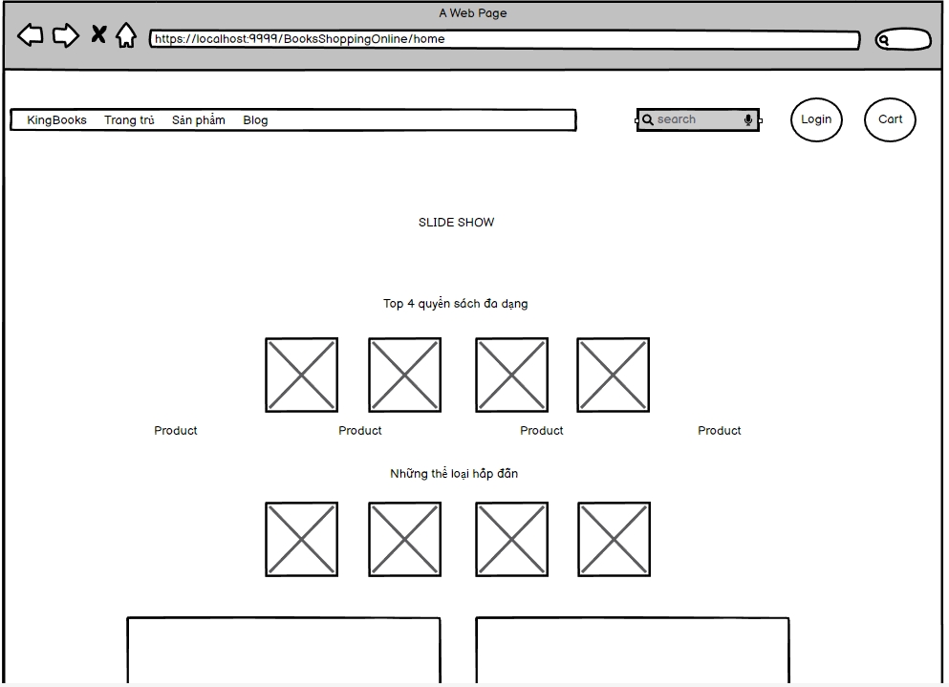

### 

### 

* Function Details:
  + Display header bar including: homepage, products, search bar and button to login with shopping cart.
  + Shown slider information includes its image and title; the user is redirected to the slider's backlink on his/her clicking.
  + Shown post information includes its thumbnail, title, brief-info; the user is redirected to the post's details on his/her clicking.
  + Shown product information includes its thumbnail, title, brief information; the user is redirected to the product's details on his/her clicking.
  + Show Blogs information includes its thumbnail, title, brief-info; the user is redirected to the post's details on his/her clicking.
  + Show footer have google map and address contract.

### b. Blog List

* Function trigger: This function is triggered when the user clicks to Blog on header.
* Function description: Show the posts paginatedly (sorted by updated date, paginated) with the post search box, post categories, the latest posts, and static contacts/links; Shown post information includes its thumbnail, title, brief-info; the user is redirected to the post's details on his/her clicking
* Screen layout: mockup prototype of the screen, sample below is for Blog list screen

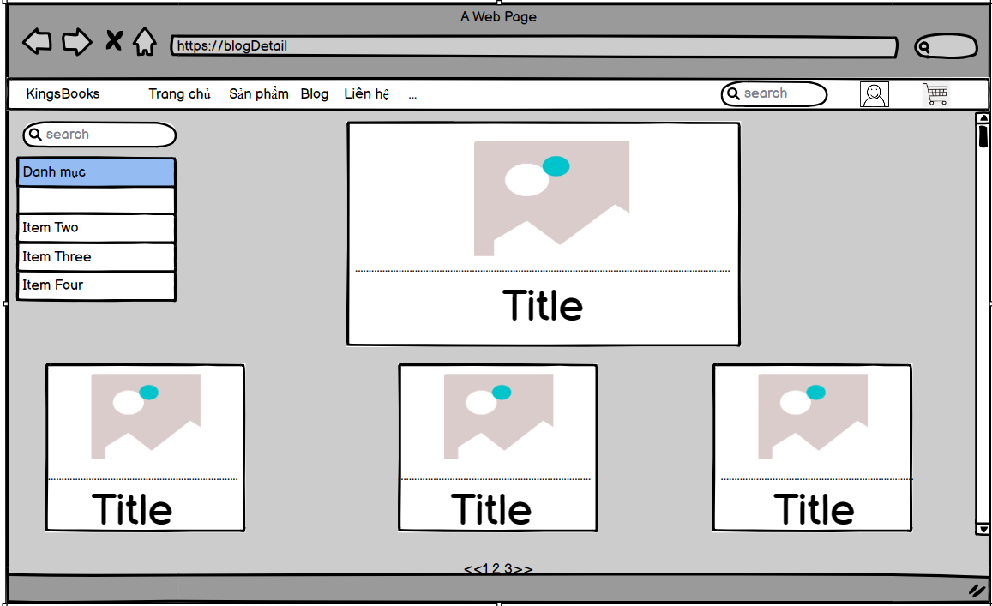

* Function Details: When the page loads for the first time, it will display all the products, categories in the database.
  + When clicking on the search bar, the keyword will be transmitted for processing and will return the product page containing that keyword.
  + When clicking on the dropdown for the category, selecting a category in it, the page will return products with the same selected category.
  + Clicking on a specific product will take you to the Product detail screen for that product.

### c. Blog Detail

* Trigger function: This function is activated when user clicks on any post from BlogList
* Description Function: User can view post details
* Screen layout: simulated prototype of the screen, the sample below is for the Blog Detail screen

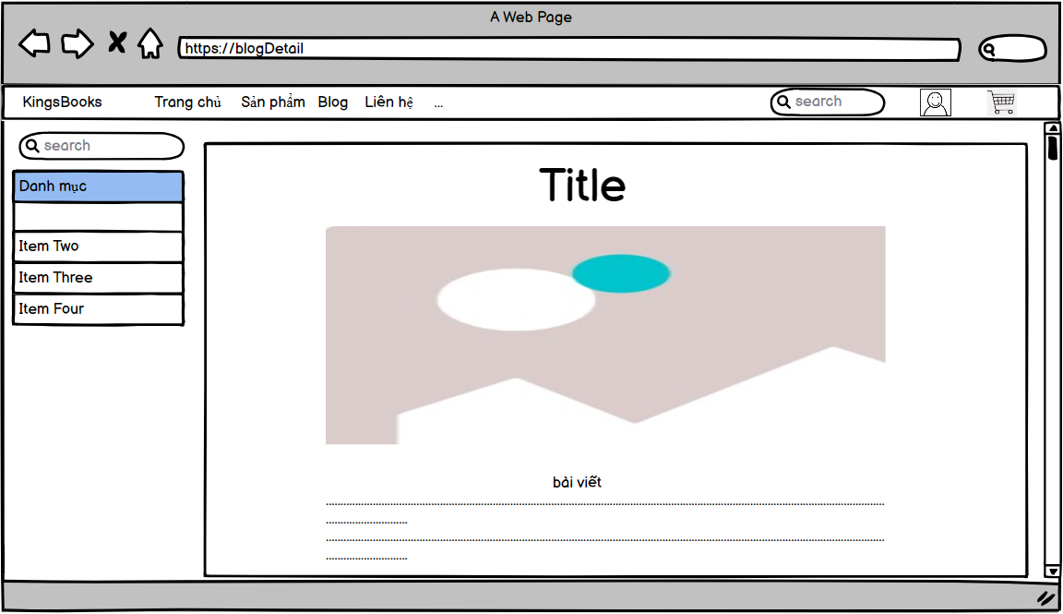

* Function details:

Show post details as a result of user clicking on the post. Display the title of the article so that the reader knows the main content of the article. Displays information about the author of the article and the date the article was published. Show full content of the post

### d. Products List

* Function trigger: This function is triggered when the user clicks to Product( Sản Phẩm) on header.
* Function description: Show the products paginated (sorted by updated date) + the slider with the product search box, product categories, the latest products, and static contacts/links
  + Shown product information includes its thumbnail, title, brief information, original price, and sale price.
  + The user is redirected to the product's details on his/her clicking on the product.
  + The user can choose to add the product to the cart or to feedback on the product by clicking the product's Buy & Feedback buttons responsively.
* Screen layout: mockup prototype of the screen, sample below is for Product list screen

* Function Details: When the page loads for the first time, it will display all the products, categories, and sliders in the database.
  + When clicking on the search bar, the keyword will be transmitted for processing and will return the product page containing that keyword.
  + When clicking on the dropdown for the category, selecting a category in it, the page will return products with the same selected category.
  + When clicking on the dropdown for sorting, choosing a sort, the page will return the products after being sorted according to that selection.
  + Clicking on a specific product will take you to the Product detail screen for that product.
  + When clicking buy now, the product will be added 1 time to the cart.
  + Clicking on the feedback will be taken to the feedback screen for that product.

### e. Product Details

* Function trigger: This function is activated when the user clicks on the Product.
* Function description:
  + Show product details (including title, category, images, original price, sale price, and product details) .
  + the sider with the product search box, product categories, the latest products, and static contacts/links
* Screen layout: mockup prototype of the screen, sample below is for Product Details screen

### 

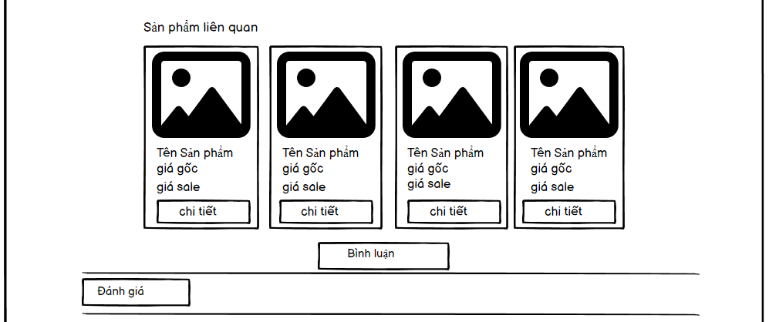

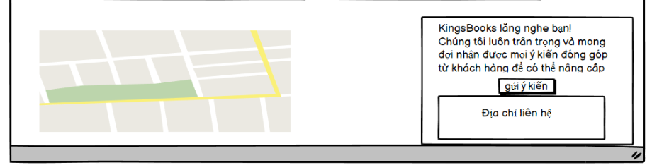

* Function Details:
  + Display user clicked products on product page. The user can choose to make a purchase or add the product to the cart. Related products displayed by product category have the same functions as in the Product List page
  + slider with product search box, product category, latest product and contact/static link Product information displayed includes thumbnail, title, details, original price and special price, quantity, color, size.

### f. Feedback

* Function trigger: This function is activated when the user clicks on the “Feedback” form
* Function Description: User can give feedback and review the product
* Screen layout: simulate the screen prototype, the sample below is a responsive screen

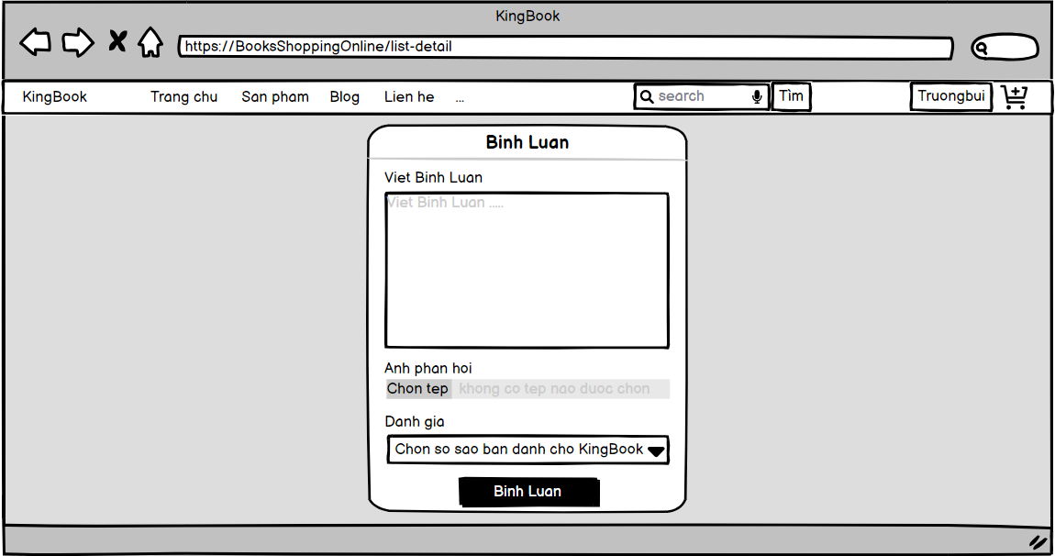

* Function details: User enters his feedback, press "comment" button to send feedback. If the user is not logged in, the screen will notify and force the user to log in. When logging in with the correct email registered with the shop, users can send product feedback

### g. Cart Detail

* Function Trigger: The Cart Detail function is activated when the user chooses to purchase or add a product to the cart.
* Function Description:
  + The Cart Detail function is responsible for displaying detailed information about the selected products in the cart.
  + Each product item in the cart will be displayed with information such as id, product name, price, quantity and total price.
  + The function also provides options for the user to continue shopping or proceed to checkout.
  + In addition, Cart Detail also provides information about the total number of products in the cart and the total amount to pay.
* Screen Layout:

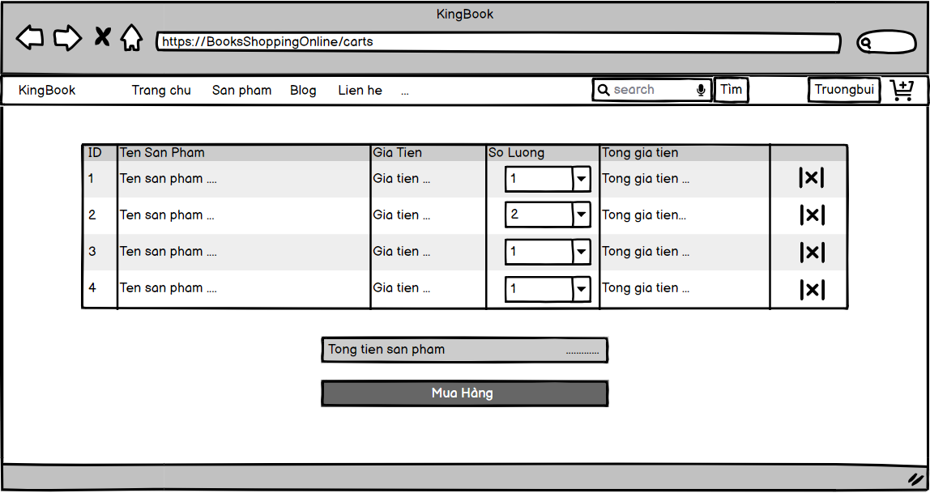

* Function Details:
  + Display a list of product items in the cart, including image, title, details, original price and special price, quantity, color, size.
  + Provide options for users to adjust product quantity.
  + Allow users to delete products they no longer want to buy.
  + Offers the option to continue shopping or proceed to checkout.
  + Display information about the total number of products in the cart and the total amount to pay.
  + Provide links or buttons to related pages such as the checkout page.

### h. Cart Contact

* Function Trigger: The Cart Contact function is activated when the user clicks on a link in the Cart Detail page.
* Function Description:
  + The Cart Contact function provides information about what is about to be paid to users so that they can pay
  + The Cart Contact page displays information such as name, phone number, email address, address, user information and information you want to buy.
* Screen Layout:
  + The Cart Contact page usually has a simple and intuitive interface.
  + Contact information such as full name, phone number, email address, address, user information and information you want to buy
  + There may be links to online payment pages

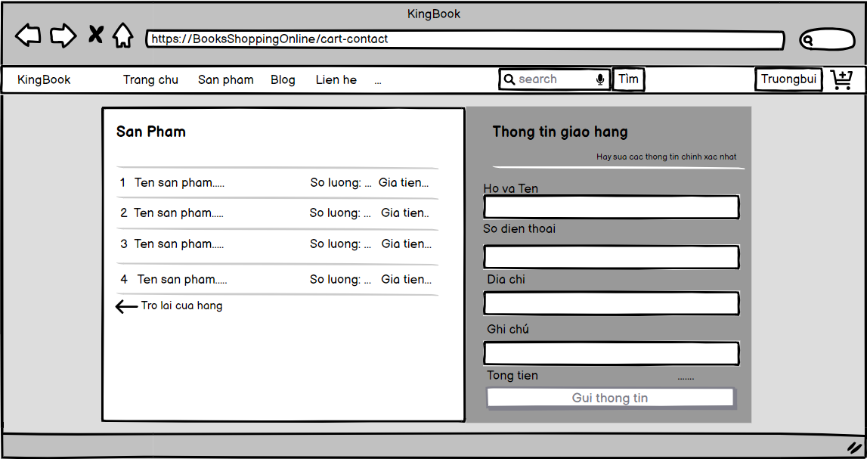

* Function Details:
  + Display contact information such as full name, phone number, email address, address, user information and information to buy
  + Users can use this information to link online payments
  + Make sure contact information is clearly displayed and easily seen for users to find and use.
  + The Cart Contact function helps users make online payments

### k. Cart Completion

* Function Trigger: The function is triggered when a user submits an order on the website or completes their shopping cart. This can be initiated by the user clicking on a "Submit Order" button or a similar action.
* Function Description: The function performs several tasks upon order submission. It updates the order status to "submitted," updates the available quantities of the products in the inventory, automatically assigns the order to active sellers in a rotational manner, stores the latest receiver information if it is new or changed, and sends order confirmation and payment guides to the customer via email.
* Screen Layout:
  + The screen layout consists of the following elements:
  + Cart completion notes: Displays any relevant information or instructions for the customer to complete their order.
  + Static contacts/links: Provides static contact information or links to additional resources.

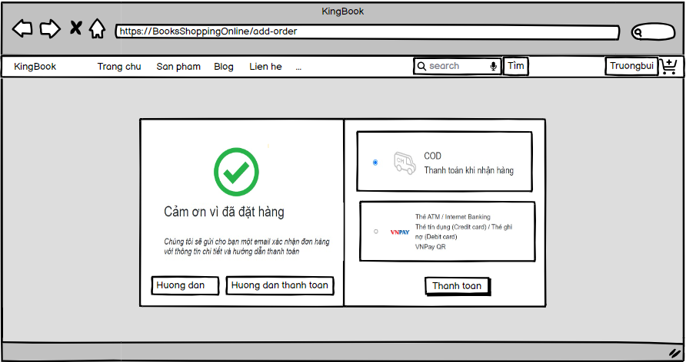

* Function Details:
  + Order Status Update:

Trigger: Order submission by the customer.

Action: Change the order status to "submitted."

* + Update Available Quantities:

Trigger: Order submission by the customer.

Action: Adjust the available quantities of the products in the inventory based on the items in the submitted order.

* + Automatic Assignment of Orders:

Trigger: Order submission by the customer.

Action: Automatically assign the submitted order to active sellers in a rotational manner. This ensures a fair distribution of orders among sellers.

* + Order Payment Guides:

Trigger: Order submission by the customer.

Action: Send an order confirmation email to the customer's provided email address. The payment information, such as banking account details, should be fetched from the system configuration file.

## 2. Common Feature

### a. User Login

* Function trigger: This function is triggered when the user Click the button on the 2nd header bar from left to right wil show form “Đăng Nhập” from “Trang Chủ”
* Function description: User sign in into the system.
* Screen layout: mock-up prototype of the screen, sample below is for the Login screen

* Function Details:
  + When the page loads for the first time, it will display the homepage.
  + When clicking on the login button on the homepage, have a login pop-up.
  + When entering username and password, then click on button login.
  + If username or password are correct, the page will return homepage and have a button logout.
  + If username or password are incorrect, have a notify "Username or password are incorrect"
  + Clicking on "Quên mật khẩu" will take you to the reset password screen for user.
  + Clicking on "Đăng ký" will take you to the register screen for users.

### b. User Register

* Function trigger: This function is triggered when the guest goes to login and choose to register
* Function description: The guest can create an account.
* Screen layout: mock-up prototype of the screen, sample below is for the Register.

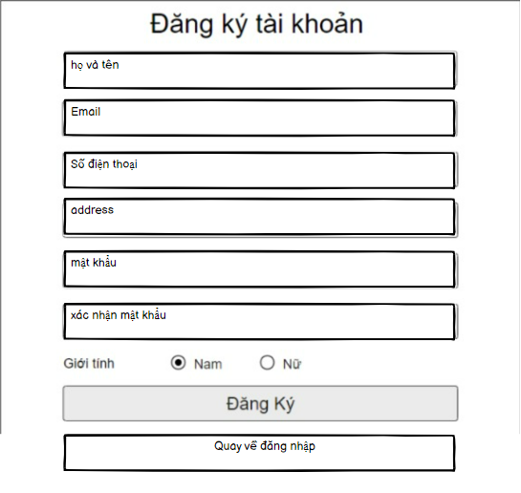

* Function Details:
  + When the page loads for the first time, it will display the homepage.
  + When click on button login on homepage, have a login pop-up, and click on button register to have a register pop-
  + When entering username and password, then click on button login.
  + If username or password doesn't exist, the page will return homepage and have a button logout.
  + If username exist, have a notify "Username exist"
  + If password and re-password aren't the same, have a notify "password and repassword aren' the same"
  + Clicking on "Quên mật khẩu" will take you to the reset password screen for user.
  + Clicking on "Đăng nhập" will take you to the login screen for the user.

### c. Reset Password

* Function trigger: This function is triggered when the user clicks “Quên mật khẩu” form Đăng nhập
* Function description: The user can Reset Password to an account.
* Screen layout: simulated prototype of screen, below sample is for ResetPassword screen

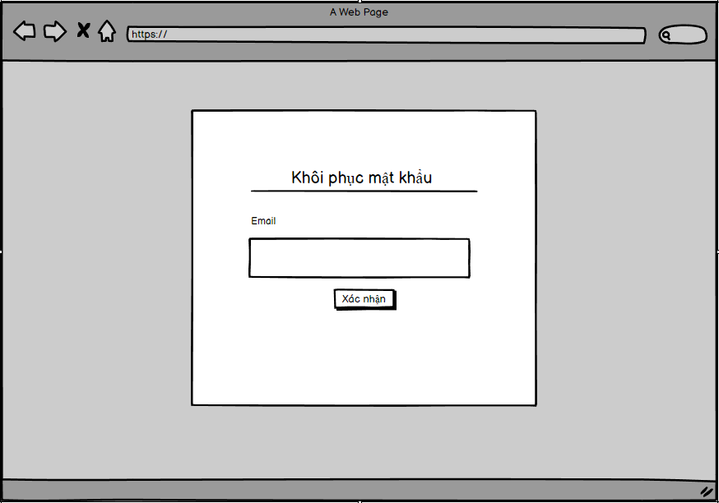

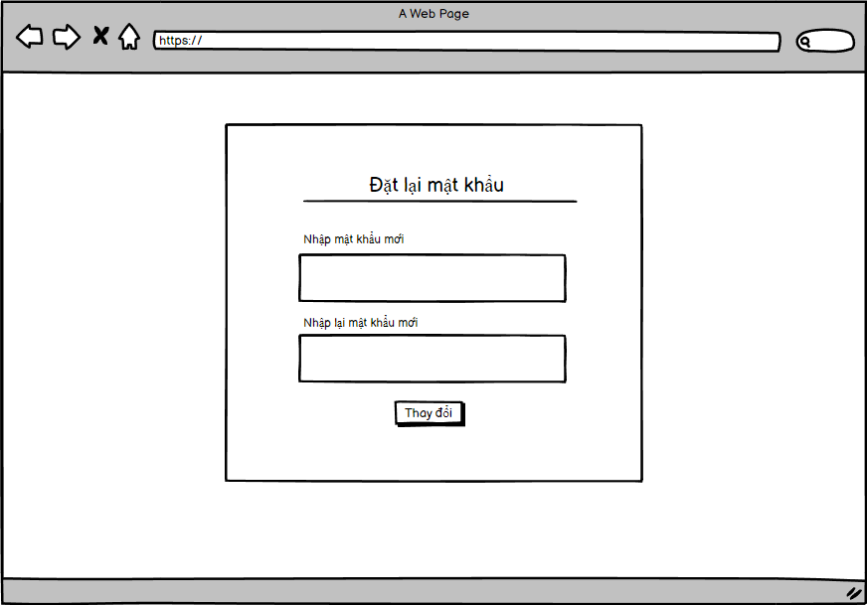

* Function Details:
  + User enters his email, clicks "Xác nhận" button to receive password reset link.If email does not exist in the shop, will receive notification and be allowed to re-enter. When entering the correct email registered with the shop, this link is sent to the user's email to reset their password.
  + When the link is clicked, the user is directed to the reset password page, where they enter the new password (twice) to access the system and return to the home page

### d. Change Password

* Function trigger: This function is triggered when the user clicks “Đổi mật khẩu” from user profile in Homepage
* Function description:User to change his password by entering current password as well as new password (twice)
* Screen layout: simulated prototype of screen, below sample is for ChangePassword screen

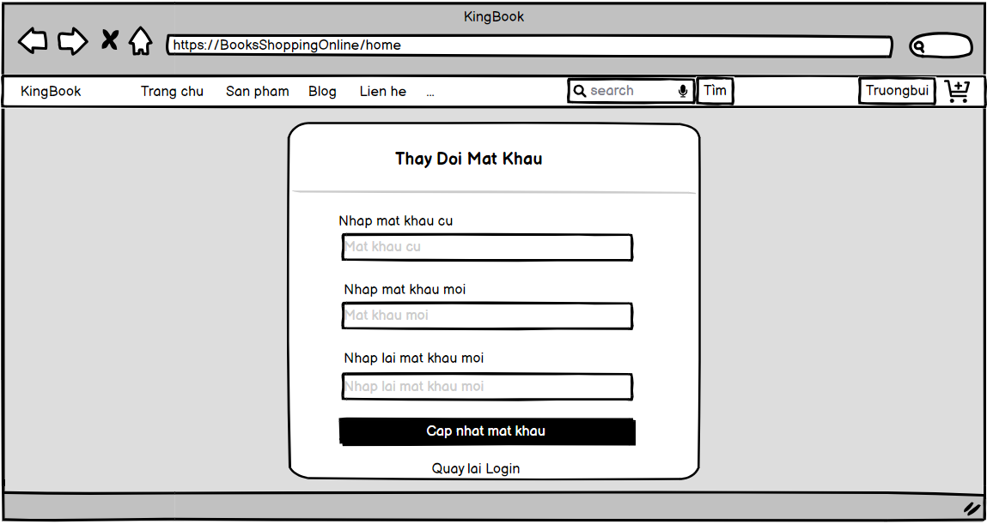

* Function Details: User enters the old password and enters the desired new password (twice),then clicks the "Thay đổi" button. If the old password is wrong, or 2 new passwords that are not the same will receive a notification. When the old password is entered correctly and the 2 new passwords are the same, the password change is successful

### e. User Profile

* Function trigger: This function is triggered when the user clicks “Tài khoản của tôi” from Home
* Function description: The user can edit his/her profile information, including the registered user information and the avatar image.
* Screen layout: simulated prototype of screen, below sample is for User profile screen

### 

### 

|  |
| --- |

### 

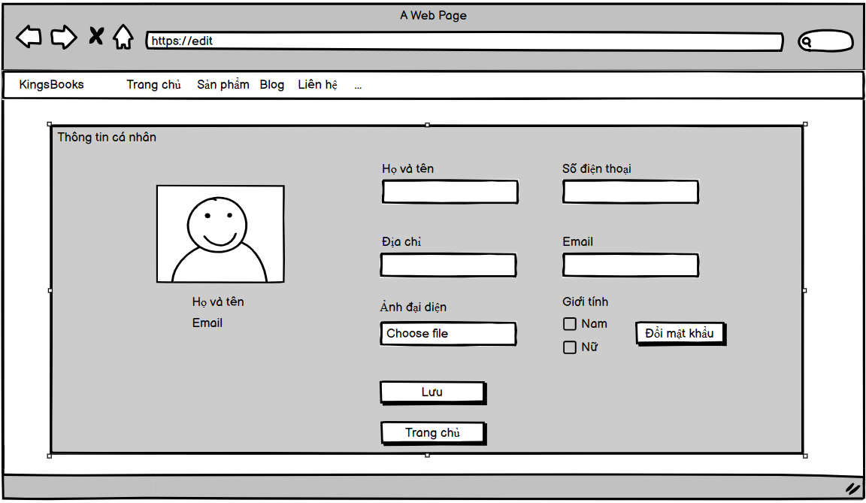

* Function Details:
  + The user can edit his/her profile information.
  + Clicking on "Đổi mật khẩu" will take you to the change password screen for user.
  + Clicking on "Lưu" will take you to save information for the user.
  + Clicking on "Quay lại" will take you to the homepage screen for the user.

**f. User Authorization**

* Function trigger: This function is triggered when the user clicks “Display Info” form.DropDown.
* Function description: When the login is successful, what functions will the user be authorized to use?
* Screen layout: simulated prototype of screen, below sample is for User Authorization Screen.

-follow roll customer.

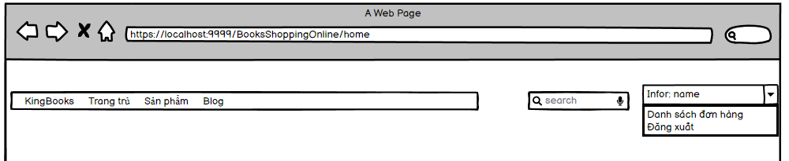

-follow roll marketing

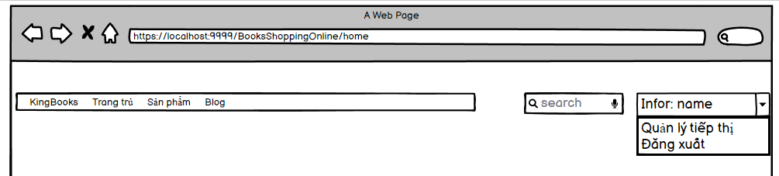

–follow role sale and sale management.

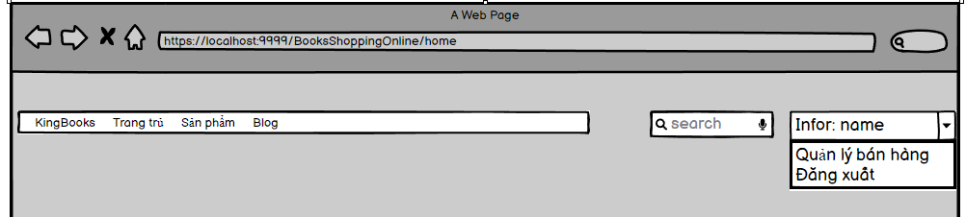

-follow roll admin

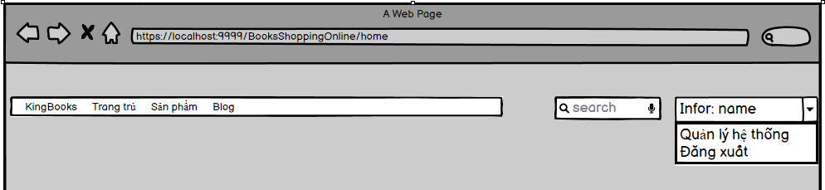

* Function Details:
  + upon successful login. will display the main function according to that user's role. When clicked, it will take the user to the Screen containing that function.

### f. User Authorization

* Function trigger: This function is triggered when the user intentionally accesses the unauthorized path
* Function description: when the user tries to access the unauthorized link, will display the message to the user and authorize users to access.
* Screen layout: simulated prototype of screen, below sample is forAuthorization.

-follow roll customer.



-follow roll marketing



–follow role sales and sales management.



-follow role admin



-when the user tries to access the unauthorized link

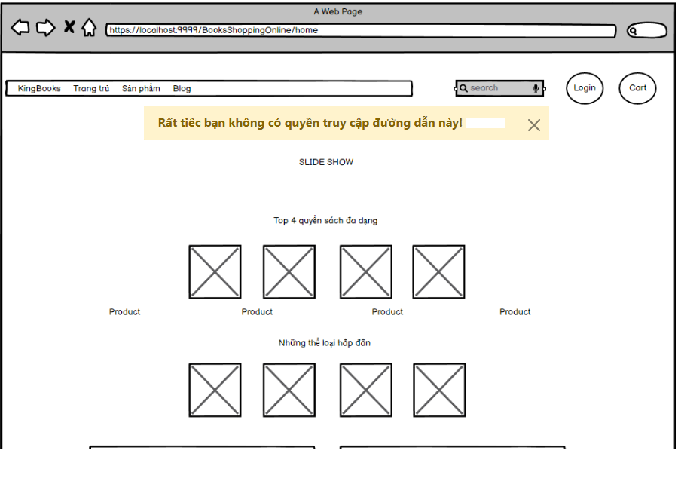

* Function Details:
  + when the user tries to access the unauthorized link, will display the message in home page"Rất tiêc bạn không có quyền truy cập đường dẫn này! "
  + authorize users to access the corresponding function according to their Role when successfully logged in and Click on the login button on the header bar to display a list of form DropDown functions

## 

## 3. Customer Feature

### a. My Orders

* Function trigger: This function is triggered when the user clicks “Danh sách đơn hàng” from Home
* Function description: Show the list of user's orders paginatedly + the sider with the product search box, product categories, the latest products, and static contacts/links
* Screen layout: simulated prototype of screen, below sample is for My Orders screen

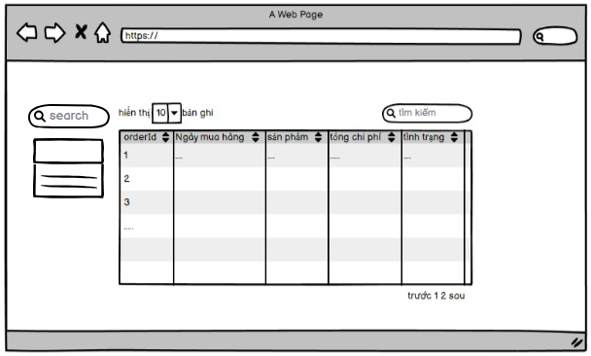

* Function Details:Display order information including: id, ordered date, product (first product name & number of other products if any), total cost, status.

### b. Order Information

* Function trigger: This function is triggered when the user clicks the link under the order id from My Orders.
* Function description:Show the order details, including the information as below + the sider with the product search box, product categories, the latest products, and static contacts/links
* Screen layout: simulated prototype of screen, below sample is for Order Information screen.

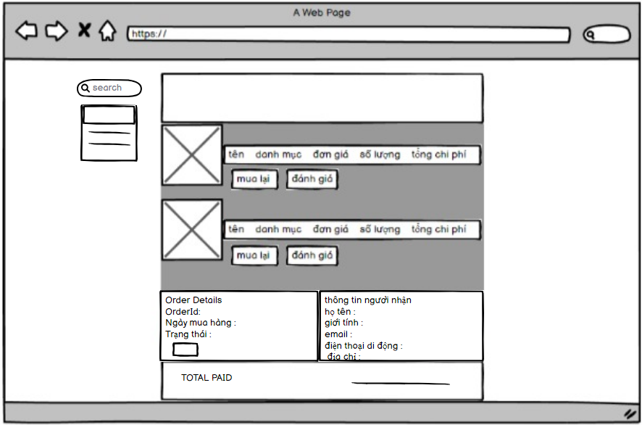

* Function Details:Display order details including:
  + The order id, order date, total cost, status.
  + The receiver information: full name, gender, email, mobile.
  + This list of ordered products, each product include following information & the links/buttons that allow the user to re-buy or feedback: thumbnail, name, category, unit price, quantity, total cost.

## 4. Marketing Feature

### a. MKT Dashboard

* Function trigger: This function is triggered when the user clicks “Quản lý tiếp thị” from Home
* Function description: Show statistics of posts, products, customers, feedbacks & the trend of new customers by day for the last 7 days (the start date & end date can be adjustable)
* Screen layout: simulated prototype of screen, below sample is for MKT Dashboard screen

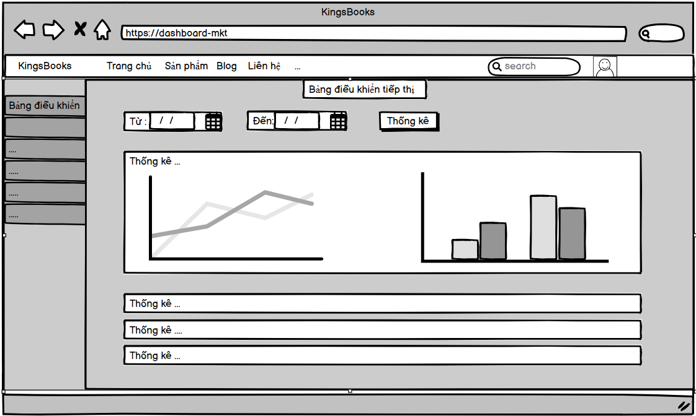

* Function Details:
  + Users can view statistics of new posts, products, customers, feedback & trends
  + User can choose the period of statistics
  + Clicking on "Thống kê" will display a graph of statistics by category

### b. MKT Product List

* Function trigger: This function is triggered when the user clicks “Quản lý sản phẩm” from left board
* Function description: 'Show the paginated list of posts (include posts' id, thumbnail, title, category, author, featured, and status information):
  + The user can filter the post by category, author, status or search by title
  + Sortable by title, category featured, or status
  + From each post, the user can choose to hide, show, view, edit it
  + The page also have the button/link that allows the user to add new post
* Screen layout: simulated prototype of screen, below sample is for MKT Product lists screen

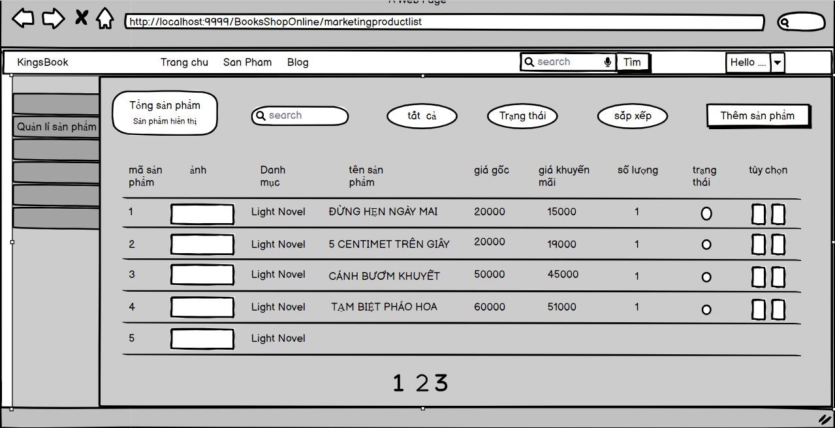

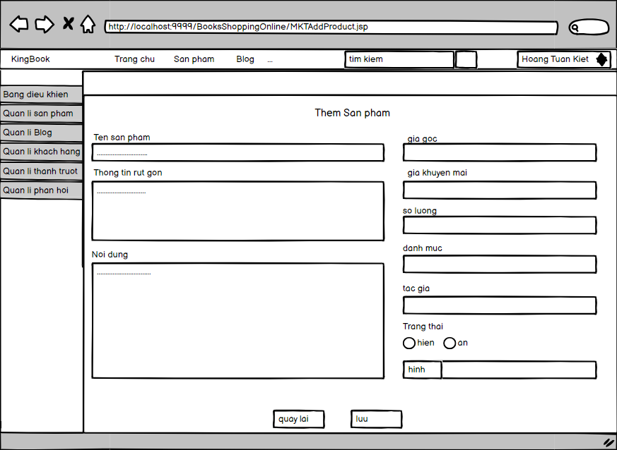

* Function Details:
  + upon successful login. will display the main function according to that Maketin's role. When clicked, it will take the user to the Screen containing that function.
  + When clicking on "Quản lý sản phẩm" from the left board of the screen will display a list of all products combined with pagination.
  + MKT can search for products by product name, category in the search box.
  + MKT Can filter products by category, status when clicking "tất cả", "trạng thái"
  + MKT can sort products by price, date-update when clicking on "Sắp xếp"
  + MKT can add new products by clicking the "Thêm sản phẩm" button.
  + MKT can also adjust the product status and edit the product by clicking the buttons in the "Tùy chọn" column.

### c. MKT Slider List

* Function trigger: This function is triggered when the user clicks “Quản lý thanh trượt” from left board
* Function description: 'Show the paginated list of sliders (including sliders' id, title, image, backlink, status)

- The user can filter the sliders by the status + search by title or backlink

- For each slider, the user can choose to hide, show, edit it

* Screen layout: simulated prototype of screen, below sample is for MKT Slider lists screen

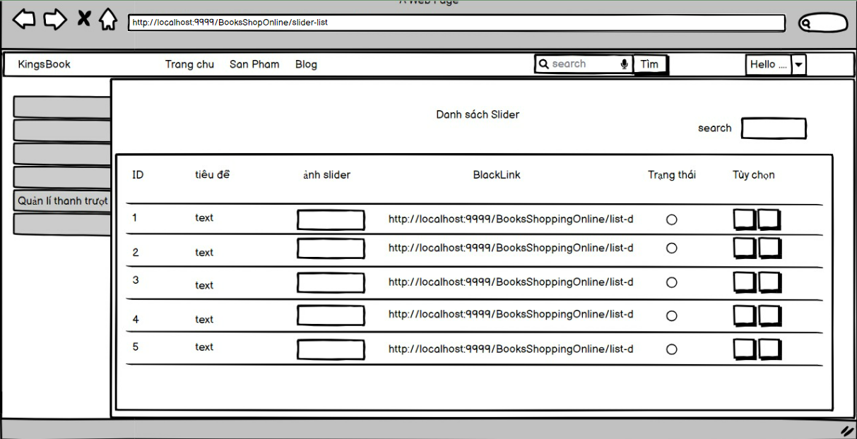

* Function Detail:

upon successful login. will display the main function according to that Marketing's role. When clicked, it will take the user to the Screen containing that function.

* + When clicking on "Quản lý Thanh trượt" from the left board of the screen will display a list of all sliders
  + MKT can search for sliders by title or blacklink in the search box.
  + MKT can filter the sliders by the status when clink “trạng thái”
  + MKT can also adjust the product status hide, show and edit the slider by clicking the buttons in the "Tùy chọn" column.

### d. MKT Product Detail

* Function trigger: This function is triggered when the user clink botton “edit” from MKT Product List screen
* Function description: Show detailed product information (thumbnail, category, title, brief information, attached images, description, quantity, list price, sale price, flag to turn the featurning on/off, status)
  + from that allow the user to input, view or edit them
* Screen layout: simulated prototype of screen, below sample is for MKT Product detail screen

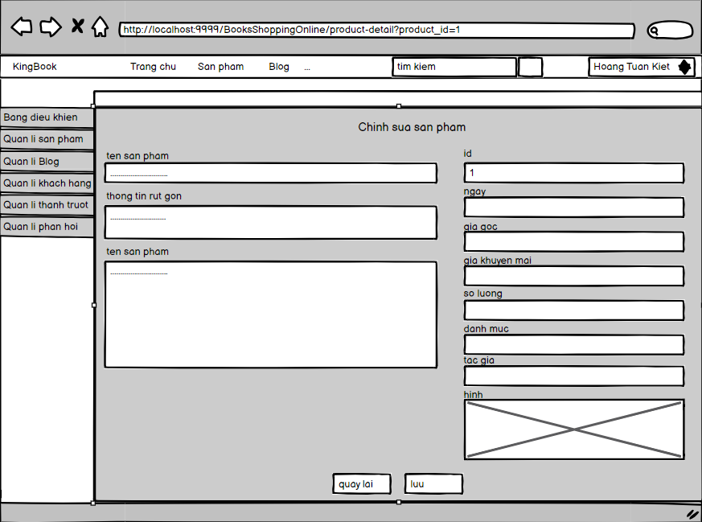

* Function Details:
  + upon successful login. will display the main function according to that Maketing's role. When clicked, it will take the user to the Screen containing that function.
  + When clicking on button "edit" from column “tuy chon” in the MKT Product List of the screen will display a detail products.
  + MKT can view and edit products by product id
  + MKT need to fill into all empty column for detail
  + MKT can update product by clink the “luu” button
  + MKT can return to MKT Product List by clink the “Quay lai” button

### e. MKT Slider Detail

* Function trigger: This function is triggered when the user clink botton “edit” from MKT Slider List screen
* Function description: 'Show detailed slider information (image, title, backlink, status, notes)
* Screen layout: simulated prototype of screen, below sample is for MKT Slider detail screen

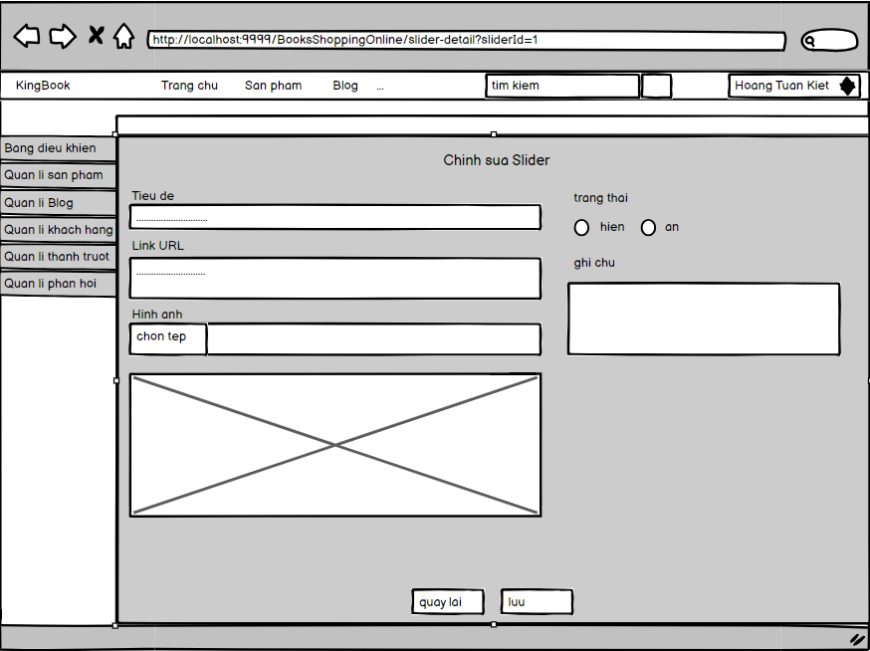

* Function Details:
  + upon successful login. will display the main function according to that Maketing's role. When clicked, it will take the user to the Screen containing that function.
  + When clicking on button "edit" from column “tuy chon” in the MKT Slider List of the screen will display a detail sliders.
  + MKT can view and edit Slider by sliderid
  + MKT need to fill into all empty column for detail
  + MKT can update slider by clink the “luu” button
  + MKT can return to MKT Slider List by clink the “Quay lai” button

### f. MKT PostsList

* Function trigger: This function is triggered when the user clicks “Quản lý Blog” from left board
* Function description: Show the paginated list of posts (include posts' id, thumbnail, title, category, author, featured, and status information):
  + The user can filter the post by category, author, status or search by title
  + Sortable by title, category, author, featured, or status
  + From each post, the user can choose to hide, show, view, edit it
  + The page also have the button/link that allows the user to add new post
* Screen layout: simulated prototype of screen, below sample is for MKT Blog lists screen

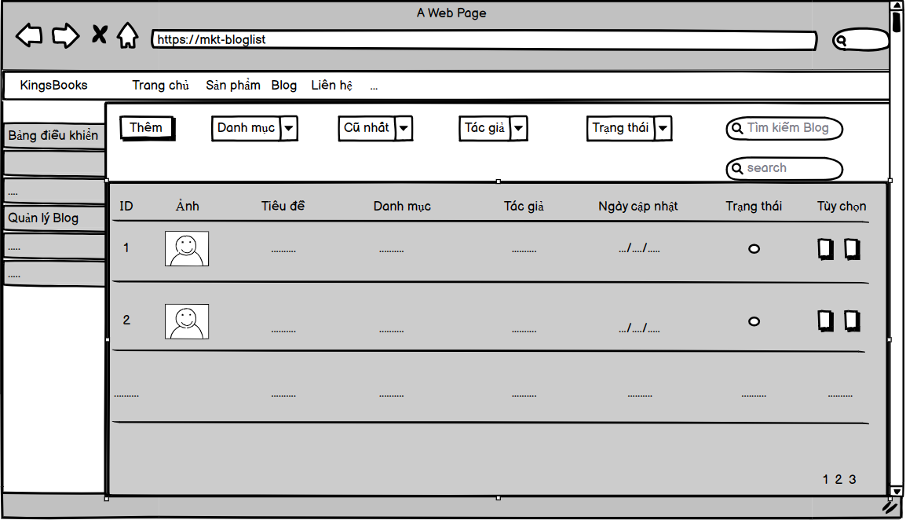

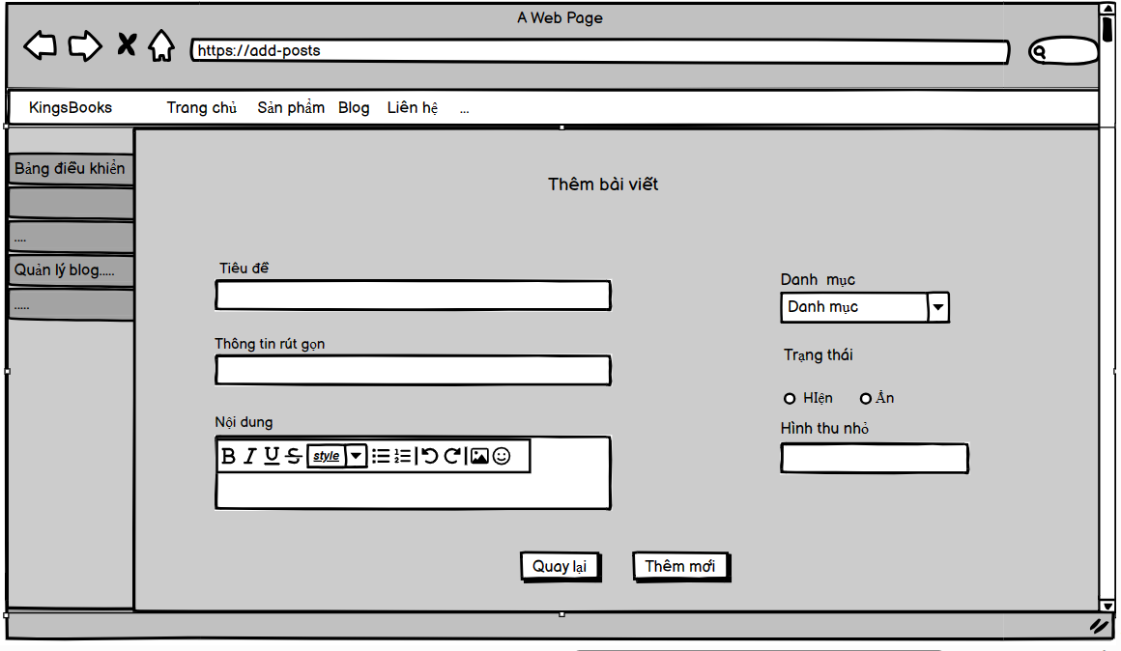

* Function Details:
  + When successful login. will display the main function according to that Maketing's role. When clicked, it will take the user to the Screen containing that function.
  + When clicking on "Quản lý Blog" from the left board of the screen will display a list of all blogs
  + MKT can search for blogs by title in the search box.
  + MKT can filter the blogs by the ID, title,category, author and status when click
  + MKT can also adjust the blog status hide, show and edit the blog by clicking the buttons in the "Tùy chọn" column**.**

### g. MKT Posts Detail

* Function trigger: This function is triggered when the user clink botton “edit” from MKT Blog List screen
* Function description: Show detailed post information (thumbnail, category, title, brief information, description, flag to turn the featurning on/off, status), from that allow the user to input, view or edit them
* Screen layout: simulated prototype of screen, below sample is for MKT Blog detail screen

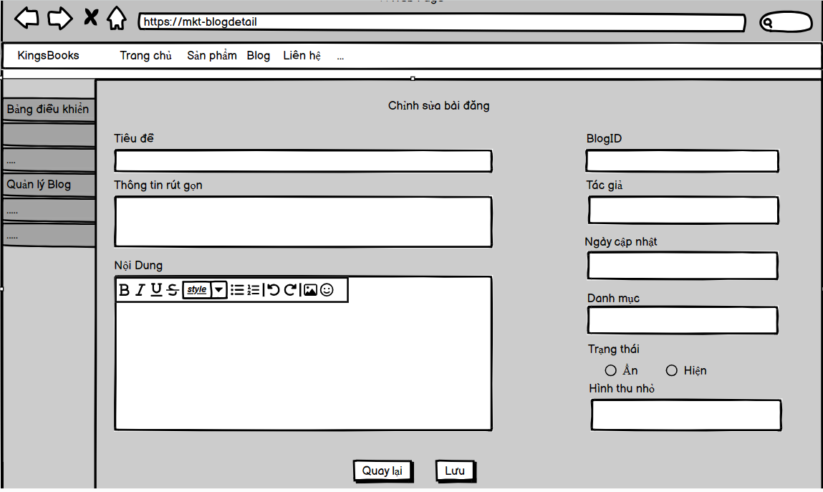

* Function Details:
  + When successful login. will display the main function according to that Maketing's role. When clicked, it will take the user to the Screen containing that function.
  + When clicking on the button "edit" from column “tuy chon” in the MKT Blog List of the screen will display a detail blogs.
  + MKT can view and edit blog by Blog id
  + MKT need to fill into all empty column for detail
  + MKT can update blog by clink the “lưu” button
  + MKT can return to MKT Blog List by clink the “Quay lai” button

### h. MKT Feedback List

* Function trigger: The Feedback List function is fired when a user requests to see a list of responses through the user interface or via an API request or similar action.
* Function description: Feedback List is a function in the system that allows users to view a list of responses. This function displays a paginated list of responses, including information about the contact's full name, product name, review stars, and the status of each response. The function provides the ability to filter responses by status, product, review star count, search by full name and response body. In addition, users can sort the list by full name, product name, review star count, and status. From the list of responses, the user can choose to view the details or change the status of each response.
* Screen layout: The Screen Layout of Feedback List includes the following components:

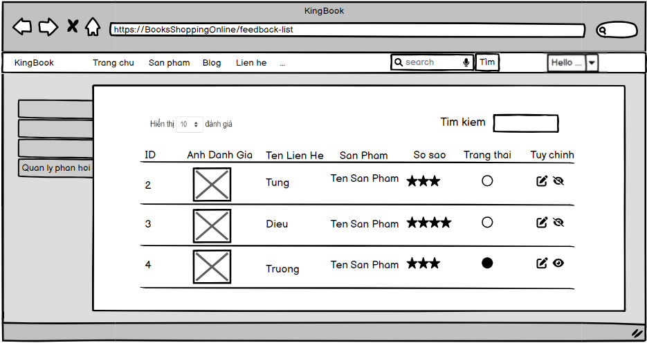

* Function Details:
  + The Feedback List function displays a paginated list of responses requested by the user.
  + Users can filter the responses by selecting the status, product or number of review stars, and can also search for responses by entering the full name or content of the response.
  + The feedback list can also be sorted by full name, product name, review stars and status by clicking on the respective column header.
  + From the response list, the user can choose to view the details of each response or change its status.

### j. MKT Feedback Detail

* Function trigger: The Feedback Detail function is triggered when the user chooses to view the details of a particular response from the feedback list, or when they interact with a specific response in the application or user interface.
* Function description: Feedback Detail is a function in the system that allows the user to view the details of a particular response. This function provides detailed information about the response, including full name, email, phone number, product, number of review stars, response body, and status. In addition, this function also allows the user to change the status of that response.
* Screen layout: The Screen Layout of Feedback Detail includes the following components:

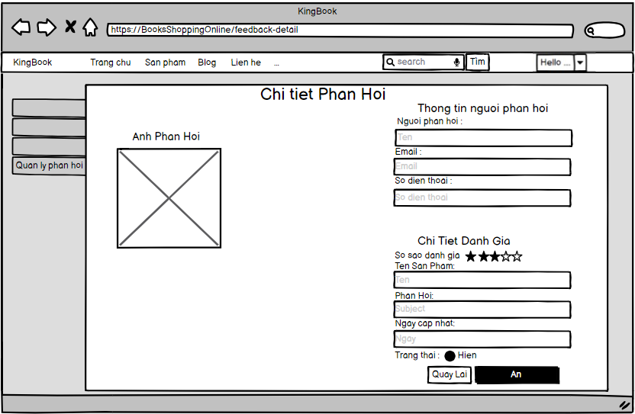

* Function Details:
  + The Feedback Detail function displays detailed information about a specific response selected by the user. This information includes your full name, email, phone number, product name involved, number of review stars, feedback, and current status.
  + If available, an image related to the response is also displayed for the user to view.
  + The user can change the status of the response from the Feedback Detail function. Typically, options are provided to change the current state of the response, such as switching to read, marking as processed, or changing other states in accordance with system or application requirements. use.

### k. MKT Customer List

* Function trigger: This function is triggered when the user clicks “Quản lý khách hàng” from left board
* Function description:Show the list of customers / contacts paginatedly (include contacts' id, full name, gender, email, mobile, status):
  + The user can filter the customers by status + search by full name, email, mobile
  + Sortable by full name, email, mobile, status
  + From each customer, the user can choose to add new, view or edit it
* Screen layout: simulated prototype of screen, below sample is for MKT Customer lists screen

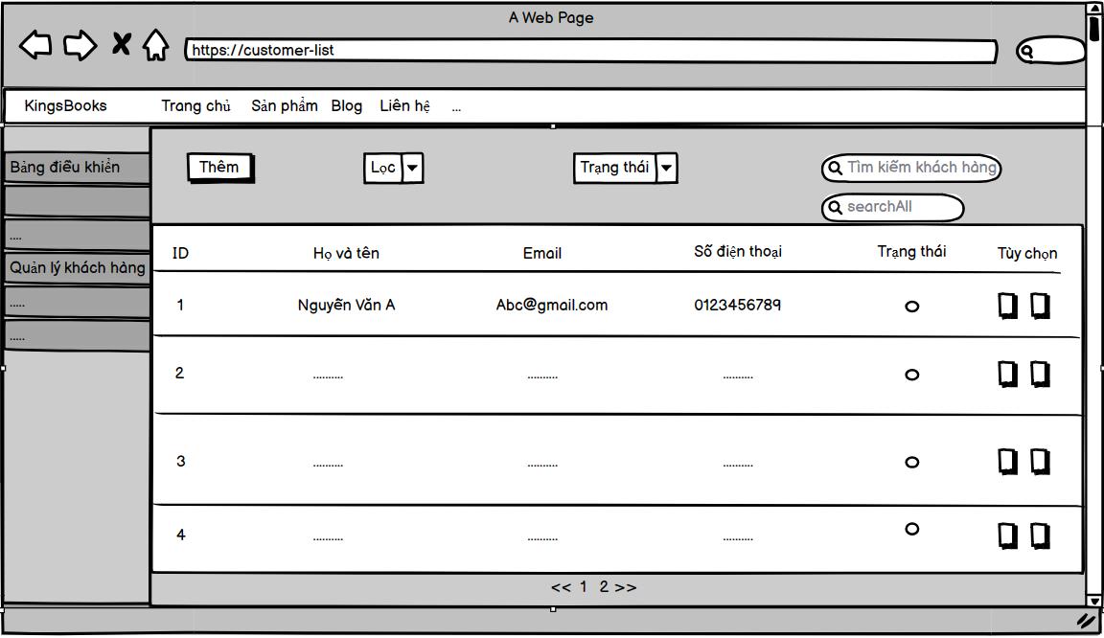

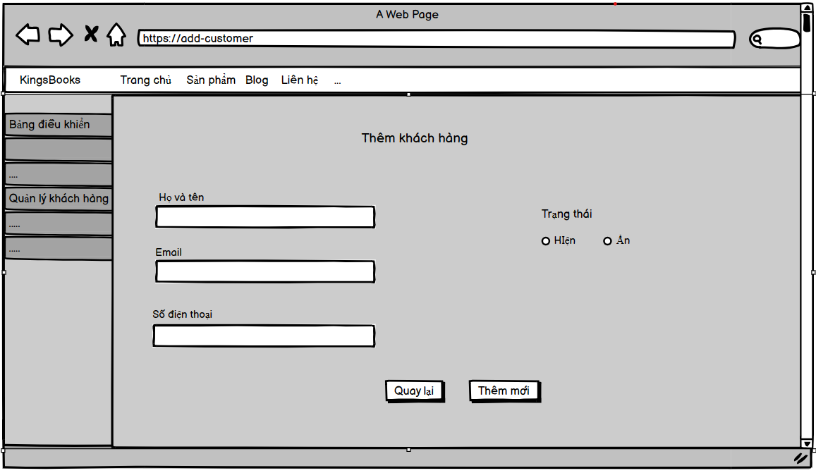

* Function Details:
  + When clicking on "Quản lý khách hàng" from the left board of the screen will display a list of all customer
  + MKT can search for customer by full name, email, mobile in the search box.
  + MKT can filter the customers by status + search by full name, email, mobile when click
  + MKT can also adjust the customer status hide, show and edit the blog by clicking the buttons in the "Tùy chọn" column.

### l. MKT Customer Detail

* Function trigger: This function is activated when the user clicks the “edit” button from the MKT Customer List screen
* Function description: Show detailed customer/contact information (full name, gender, email, mobile, address, status), from that allow the user to input, view or edit them (excep for the status which is generated automatically - contact, potential or customer)

Besides, the screen also shows the list of customer/contact changes history in the form of a table which includes following columns: email, full-name, gender, mobile, address, updated by, updated date

* Screen layout: simulate the screen prototype, the sample below is the detailed screen of the MKT Customer

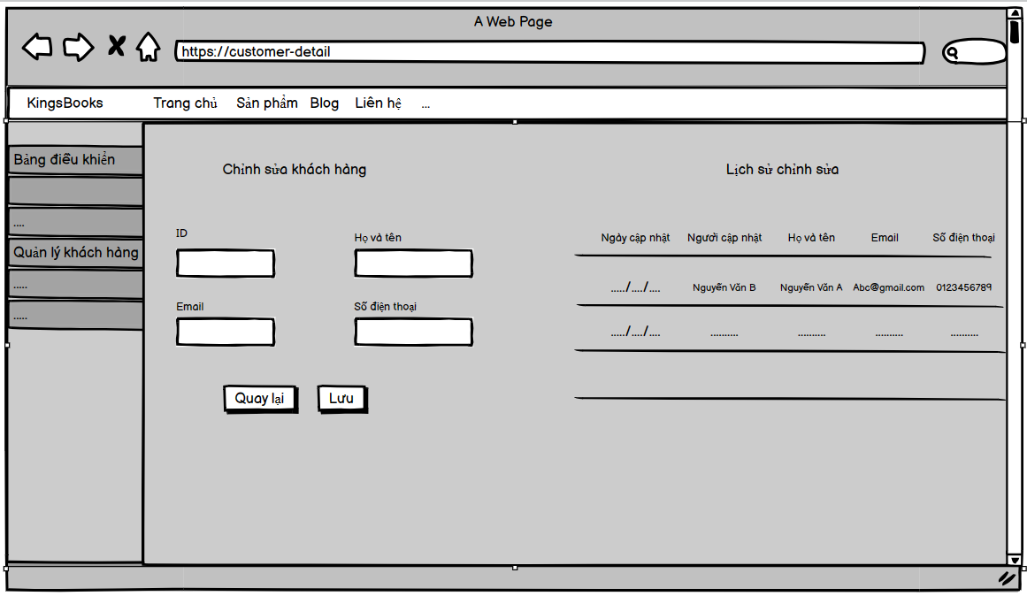

* Function Details:
  + When clicking on button "edit" from column “tuy chon” in the MKT CustomerList of the screen will display a detail customer.
  + MKT can view and edit infomation by customer id
  + MKT need to fill into all empty column for detail
  + MKT can update infomation by clink the “lưu” button
  + after pressing "lưu" will display the edit history

## 5. Sale Feature

### a. Sale Dashboard

* Function trigger: This function is activated when the user logs in with Sale and Sale manager account
* Function description: display left panel, charts show order statistics, revenue and display by search by date
* Screen layout: simulated prototype of the screen, the sample below is for the sale-dashboard screen.

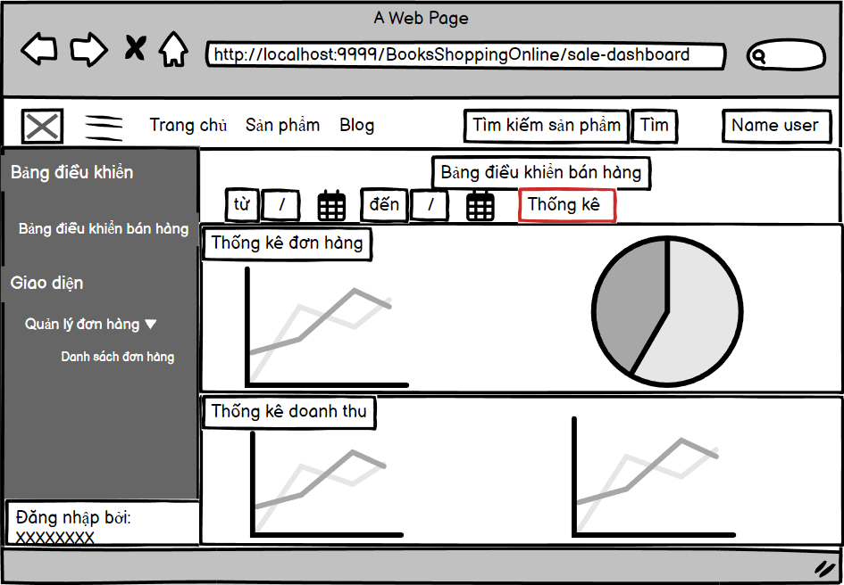

* Function Details: Select a date to view information on the chart when CLICK on the left admin panel in the console will show the admin-dashboard screen

### b. Orders List

* Function trigger: This function is activated when the user CLICK on “Danh sách các đơn hàng” when Click on the right drop down panel.
* Function description: Show the list of orders
* Screen layout: simulated prototype of screen, below sample is for Orders List screen

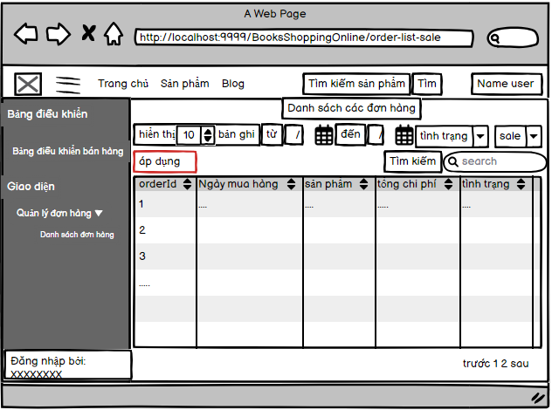

* Function Details:Show the list of orders paginatedly
  + The list can be shorted by the order date, customer name, total cost, status
  + Each order include below information: id, ordered date, customer name, product (first product name & number of other products if any), total cost, status;
  + Allow the users to filter the order by the order date (from, to), sale name, status
  + Allow the user to search the orders by order id, customer name
  + On clicking the link under the order id, user would be redirected to the Order Details page

### c. Order Details

* Function trigger: This function is triggered when the user clicks the link under the order id from Orders List.
* Function description:Show the order details.
* Screen layout: simulated prototype of screen, below sample is for Order Details screen.

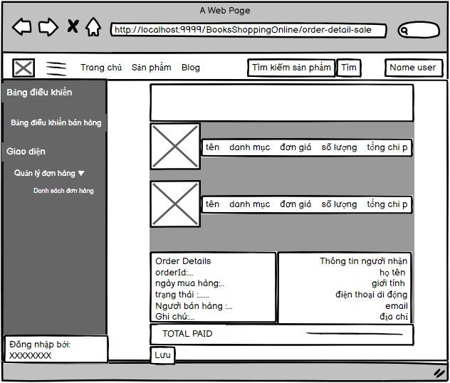

* Function Details:Show the order details, including the following information:
  + Basic order information: order id, customer full name, email, mobile, order date, total cost, sale name, status
  + The receiver information: full name, gendar, email, mobile, address
  + This list of ordered products, each product include following information: thumbnail, name, category, unit price, quantity, total cost

## 6. Admin Feature

### 

### a. Admin-dashboard

* Function trigger: This function is activated when the user logs in with ADMIN account or CLICK on “System Management” when Clicking the Dropdown panel on the right.
* Function description: display the left panel, the charts show product statistics, revenue, Rate, customers and display by search by date

● Screen layout: simulated prototype of the screen, the sample below is for the admin-dashboard screen.

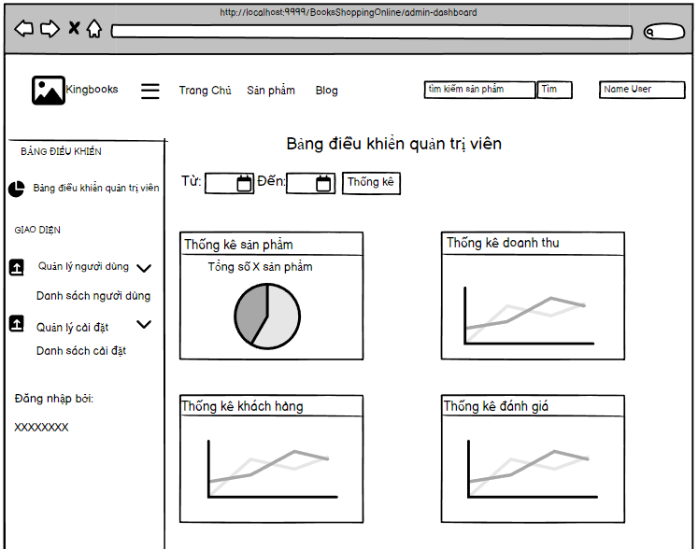

* Function Details:
  + Select a date to view information on the chart
  + when CLICK on the left admin panel in the console will show the admin-dashboard screen.
  + Click on the date selector button then click "Statistics" to display the data for the selected date range.

### b. User List

* Function trigger: This function is activated when the user CLICK on “List of users” when Click on the right drop down panel.
* Function description: display the left panel. There is an "Add" button to add a new user. display the maximum number of users in 1 page. there is a button to search and display the user table.

● Screen layout: simulated prototype of the screen, the sample below is for the User List screen.

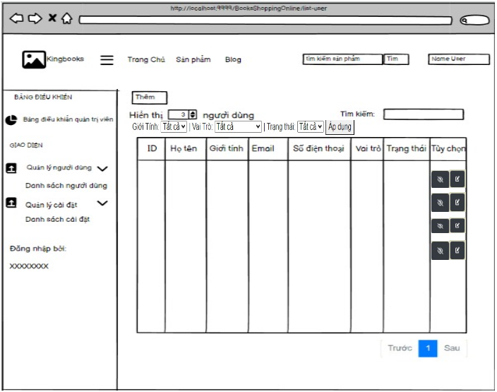

* Function Details:
  + when the user CLICK on the "Add" button will take to another page to add the user.
  + when user CLICK "Search" will search by all values present in the table
  + when user CLICK on each item like ID, Full Name will sort itself ascending, descending.
  + when user click on paging will switch to each page.
  + when clicking on the Icon in the "Tùy chỉnh" section will show hide or show status.

### c. User Details

* Function trigger: This function is activated when user CLICK on “Details” in the last column of User List
* Function description: display detailed user information, can add new users and edit old users
* Screen layout: simulate the prototype of the screen, the sample below is for the User Details screen.

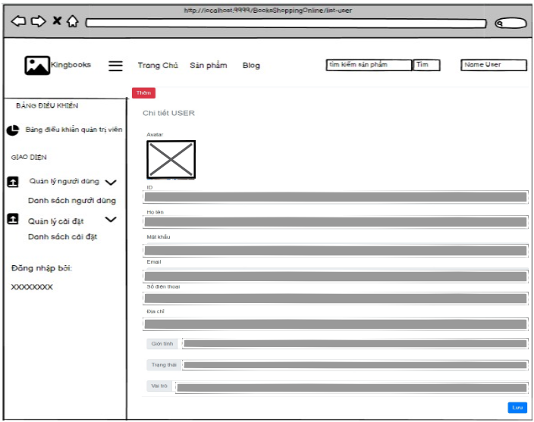

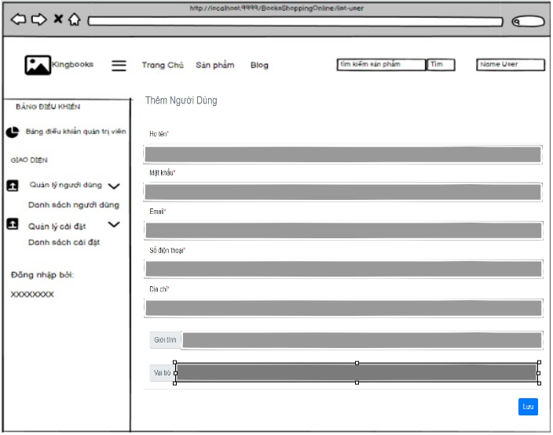

* Function details:
  + When you press the "Add" button, you will be redirected to the page to add a new user.
  + When changing information and pressing save, user information will be updated

### d. SettingList

* Function trigger: This function is activated when the user CLICK on “Danh sách cài đặt” when Click on the right drop down panel left.
* Function description: show left panel, "Add" Button , Sort follow type, ID, "Status", "search for value" and show data table

● Screen layout: simulated prototype of the screen, the sample below is for SettingList screen.

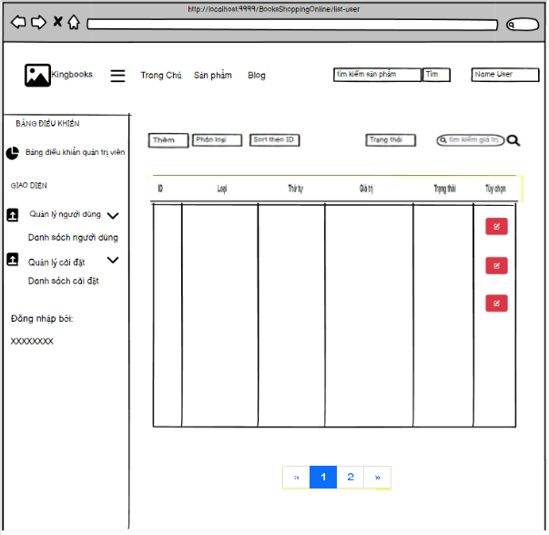

* Function Details:
  + When you press the "Add" button, you will be redirected to the page to add a new one.
  + when Click "Category" or "Incremental" or "Status" button to sort them.
  + when click "Search" button will search by "Value"
  + when user click on paging will switch to each page.
  + when clicking on the Icon in the "Tùy chỉnh" section will display another page for editing

### e. Setting Details

1: Edit Setting

* Function trigger: This function is activated when the user CLICK Icon on “Tùy chọn” when Click “Danh sách cài đặt” on the right drop down panel.
* Function description: display “ID”, "Type" , ”thứ tự” , "Value", "Description", "Status", "Back" and "Add" node.

● Screen layout: simulated prototype of the screen, the sample below is for Setting Details screen.

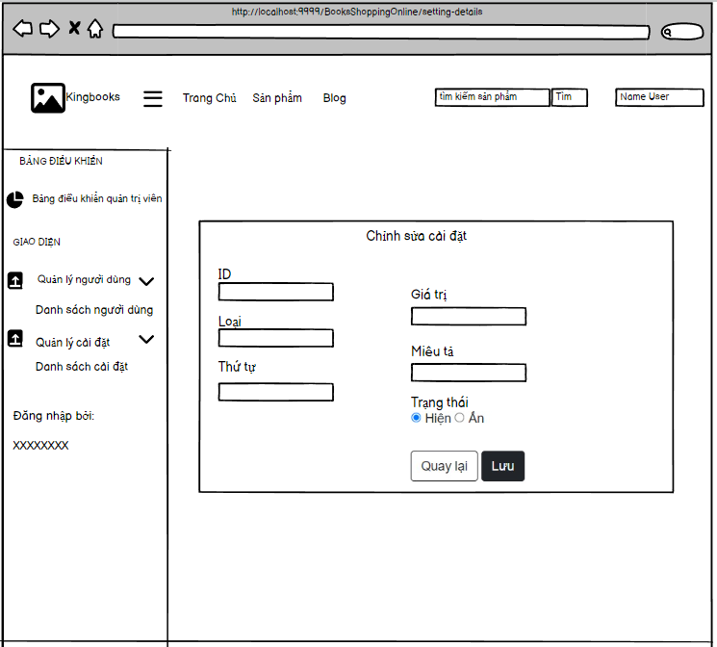

* Function Details:
  + User will be able to change the value, description and status.
  + Pressing the "Back" button will return to the previous page.
  + Pressing the "Add" button will update the changes.

2: Add Setting

* Function trigger: This function is activated when the user CLICK on “Thêm” when Click “Danh sách cài đặt” on the right drop down panel.
* Function description: display "Type" , "Value", "Description", "Status", "Back" and "Add" nodes.

● Screen layout: simulated prototype of the screen, the sample below is for Setting Details screen.

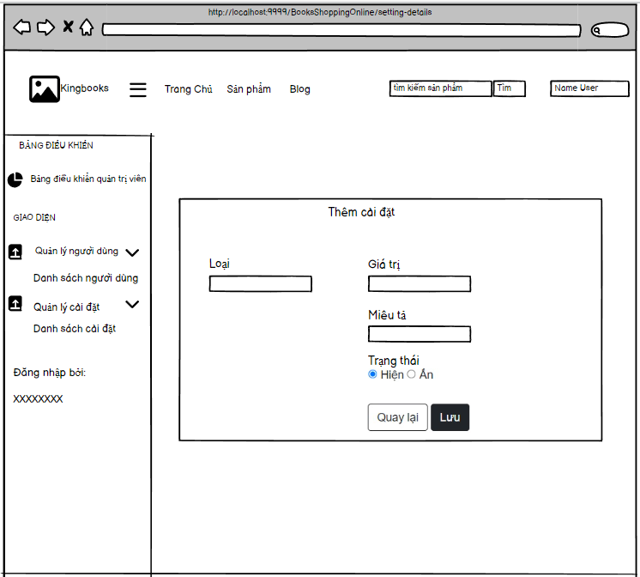

* Function Details:
  + User will be able to change the value, description and status and type.
  + Pressing the "Back" button will return to the previous page.
  + Pressing the "Add" button will update the changes.
  + when user Click on "Loại" will show the DropDown menu for user to choose.